
English


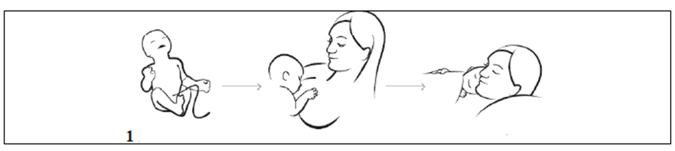
Start breastfeeding within the first hour of your baby´s life. During
that time, mother and child should possibly not be separated and stay
in skin-to-skin contact.

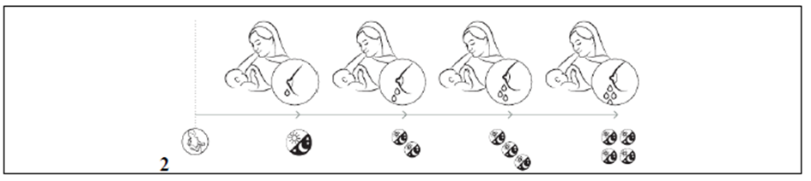
During the first days your baby receives especially valuable
colostrum – the first milk. Even though the amount is small it is usually
sufficient for your child and strengthens its immune defenses.
On the 3rd or 4th day the milk starts flowing more abundantly, you will probably
feel this engorgement by an increased tension in your breasts.


Frequent feedings, even at night guarantee an adequate milk supply.


Milk production depends on how much milk is actually wanted by
the child. In the first days additional food, liquids or pacifiers can
disturb this feedback loop and should be avoided .


Breastfeeding is the natural continuation of pregnancy. The WHO
recommends exclusive breastfeeding for a period of six months and
continued breastfeeding after introducing appropriate supplementary food up
to 2 years and beyond as long as mother and child wish.


Babies show when they want to be breastfed. They can even show this while
they sleep. They become restless, make searching head movements, sucking
sounds, open their mouth, make sucking movements and gentle noises or
hand-to-mouth movements. Crying is a very late sign of hunger.


When you put your child to the breast, make sure that the baby opens its
mouth widely, latches on the breast and takes as much breast tissue as
possible.



During the first few days, most babies lose some weight. Your baby gets
enough milk when it reaches its birth weight again at 10 days of age and then
the weight steadily increases. At about 4 months, most children have doubled
their birth weight.

